St Mary and St Benedict Catholic Primary School
PHONICS SCREENING CHECK

The Phonics Screening Check is a word reading test that all Year 1s undertake in June.
Accurate word-reading at the age of six is a good predictor of future reading success.

Children complete a word-reading check at the end of Year 1 so that parents can be confident their children are being taught to read successfully. Children read 40 words. It takes between two and five minutes.

If they do not pass the check, they are given extra support, and repeat the check at the end of Year 2.
It means that all children will be able to read accurately before they begin Year 3.
In our school, we aim to make sure that every child learns to read accurately by the end of Year 1 so they are set up for success in school and in life.
As soon as we spot a child who needs extra practice learning to read sounds and words, we teach them one-to-one for a few minutes every day.

We teach children sounds using a picture phrases to help them remember.
For example, ay, may I play? aw, yawn at dawn.
Many sounds have two or more letters making one sound. We call these ‘Special Friends’.
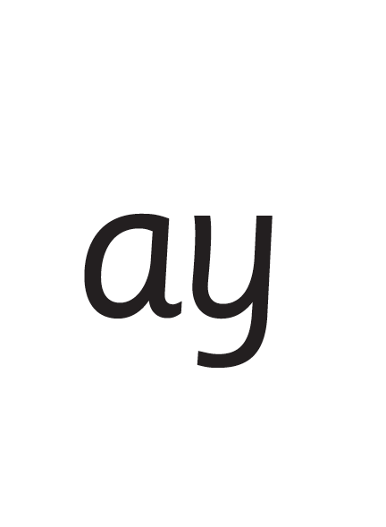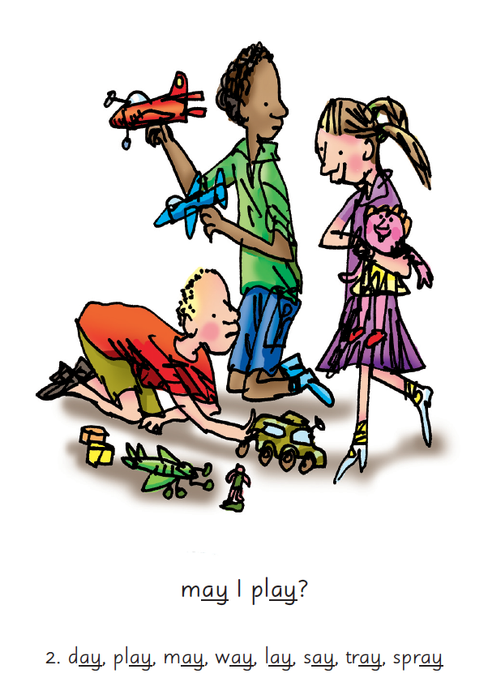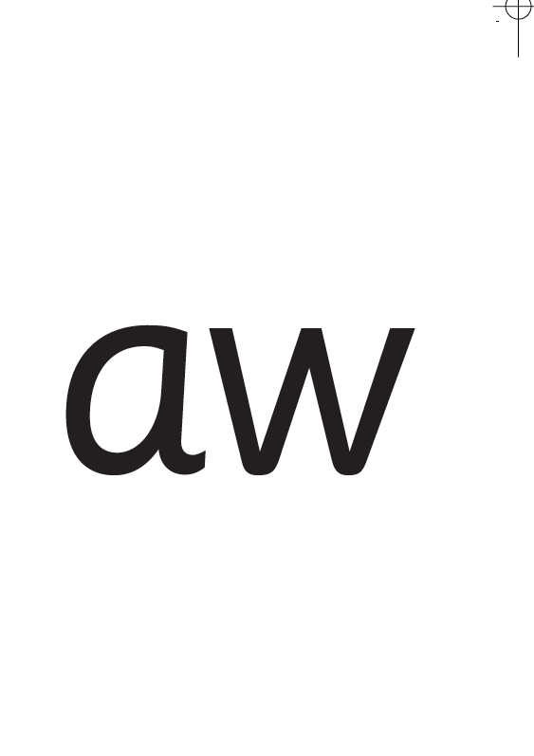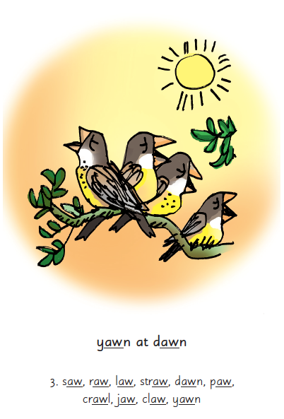
We teach children to read both real and nonsense words using the routine ‘Special Friends’, ‘Fred Talk’, read the word’.
Children spot the ‘Special Friends’ (two letters that make one sound), Fred talk the word, and then read the word as a whole.
For example, ‘sh’, sh-i-p, ship.
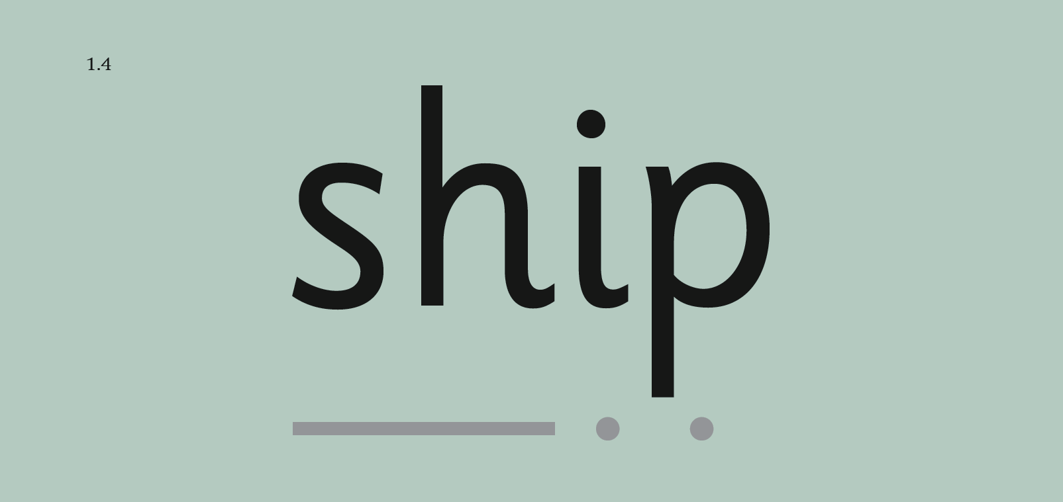
Half of the words in the check are real words.
Half are nonsense words. For example, ‘sheb’, ‘glight’, ‘ched’, ‘teb’.
There is a picture of an alien next to each word to remind the children that it isn’t a real word.
Nonsense words check that children will be able to read sounds they know in unfamiliar words.
Children who can read nonsense words will, very soon, be able to read any new word – for example – gargantuan, flailing, raucous, anticipation;
Reading new words increases children’s vocabulary rapidly.
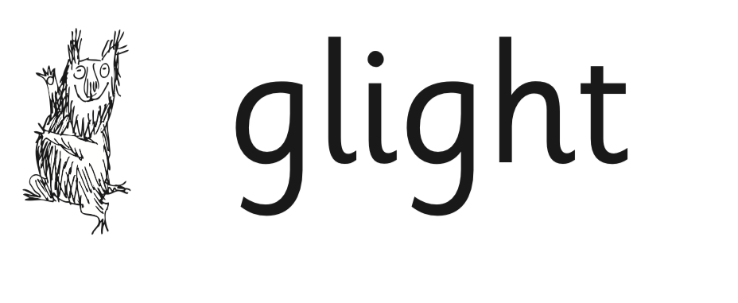

What can you do to help at home?

- Use ‘Special Friends’, ‘Fred Talk’, read the word, to read words.
- Practise reading sounds speedily - ‘review, review, review’.
- Listen to your child read their Read Write Inc. Storybook every day.

Please watch the videos on our school website with your child over the Easter holiday…

Click on Children’s Zone
Year Pages
Year 1 and 2
Phonic Screening Practice


